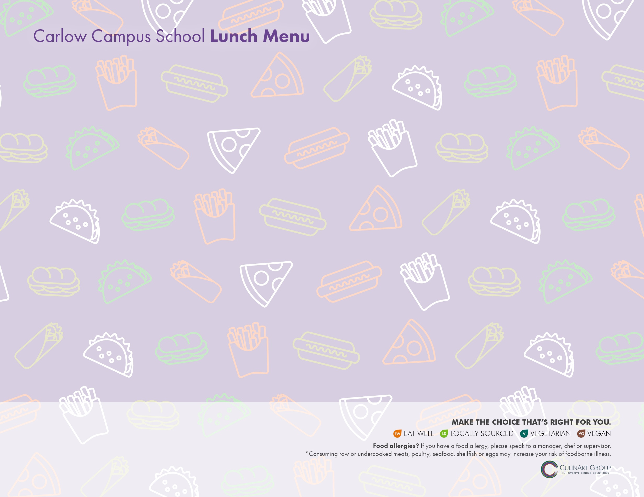**April 2021**

|  |  |  |  |  |
| --- | --- | --- | --- | --- |
| **MONDAY** | **TUESDAY** | **WEDNESDAY** | **THURSDAY** | **FRIDAY** |
|  |  |  | **1** Closed | **2 Closed** |
| **5** Closed | **6 TACO TUESDAY**  Turkey, Avocado & Cheese Quesadilla  Fiesta Power Pack – Corn Chips, Pepper Jack Cheese Cubes, Guacamole, Salsa  *Rotating Side: Fresh Mixed Fruit/ Jell-O/ Pudding* | **7** Italian Combo Wrap with Ham, Roast Beef & Salami  Celery & Carrots with Cucumber & Yogurt Dip  *Rotating Side: Fresh Mixed Fruit/ Jell-O/ Pudding* | **8** Chicken Tenders & French Fries  **OR**  Peanut butter, Apple & Honey on Whole Wheat  Veggie Sticks & Roasted Garlic Hummus  *Rotating Side: Fresh Mixed Fruit/ Jell-O/ Pudding* | **9 PIZZERIA DAY**  Cheese Pizza Bagel  Pepperoni Pizza Bagel  Garden Side Salad  *Rotating Side: Fresh Mixed Fruit/ Jell-O/ Pudding* |
| **12** Cheeseburger Snack Wrap  **OR**  Chicken Tenders & French Fries  Carrots, Celery, Tomatoes with Ranch  *Rotating Side: Fresh Mixed Fruit/ Jell-O/ Pudding* | **13 TACO TUESDAY**  Mexican Taco Snack Wrap  Fiesta Power Pack – Corn Chips, Pepper Jack Cheese Cubes, Guacamole, Salsa  *Rotating Side: Fresh Mixed Fruit/ Jell-O/ Pudding* | **14**  BBQ Veggie Hoagie  with Avocado & Cheese  Celery & Carrots with Cucumber & Yogurt Dip  *Rotating Side: Fresh Mixed Fruit/ Jell-O/ Pudding* | **15** Chicken Tenders & French Fries  **OR**  Roast Beef Sandwich  Veggie Sticks & Roasted Garlic Hummus  *Rotating Side: Fresh Mixed Fruit/ Jell-O/ Pudding* | **16 PIZZERIA DAY**  Cheese Pizza Bagel  Pepperoni Pizza Bagel  Garden Side Salad  *Rotating Side: Fresh Mixed Fruit/ Jell-O/ Pudding* |
| **19** BBQ Chicken Snack Wrap  **OR**  Chicken Tenders & French Fries  Carrots, Celery, Tomatoes with Ranch  *Rotating Side: Fresh Mixed Fruit/ Jell-O/ Pudding* | **20 TACO TUESDAY**  Taco Salad Wrap  Fiesta Power Pack – Corn Chips, Pepper Jack Cheese Cubes, Guacamole, Salsa  *Rotating Side: Fresh Mixed Fruit/ Jell-O/ Pudding* | **21** Peanut Butter & Jelly on Wheat  Celery & Carrots with Cucumber & Yogurt Dip  *Rotating Side: Fresh Mixed Fruit/ Jell-O/ Pudding* | **22** Chicken Tenders & French Fries  **OR**  Black Bean Burger on Whole Wheat Bun  Veggie Sticks & Roasted Garlic Hummus  *Rotating Side: Fresh Mixed Fruit/ Jell-O/ Pudding* | **23 PIZZERIA DAY**  Cheese Pizza Bagel  Pepperoni Pizza Bagel  Garden Side Salad  *Rotating Side: Fresh Mixed Fruit/ Jell-O/ Pudding* |
| **26** Balsamic Glazed Veggie &  Hummus Wheat Wrap  **OR**  Chicken Tenders & French Fries  Carrots, Celery, Tomatoes with Ranch  *Rotating Side: Fresh Mixed Fruit/ Jell-O/ Pudding* | **27 TACO TUESDAY**  Turkey, Avocado & Cheese Quesadilla  Fiesta Power Pack – Corn Chips, Pepper Jack Cheese Cubes, Guacamole, Salsa  *Rotating Side: Fresh Mixed Fruit/ Jell-O/ Pudding* | **28** Italian Combo Wrap with Ham, Roast Beef & Salami  Celery & Carrots with Cucumber & Yogurt Dip  *Rotating Side: Fresh Mixed Fruit/ Jell-O/ Pudding* | **29** Chicken Tenders & French Fries  **OR**  Peanut butter, Apple & Honey on Whole Wheat  Veggie Sticks & Roasted Garlic Hummus  *Rotating Side: Fresh Mixed Fruit/ Jell-O/ Pudding* | **30 Half Day** |

**ALTERNATE MEAL OPTION** Buttered Pasta

**CHOICE OF MILK** 2% White, 1% Chocolate, Strawberry, Skim or Lactaid

**CHOICE OF JUICE** Apple, Cranberry or Orange